**NAME : BHAGI RATH MANDA**

**ROLL NO : 89245**

**Assignment – 19 Views.**

1. Create a view that shows all of the customers who have the highest ratings.

Create view v1 as

Select cname, rating from customers

Where rating =

(select max(rating) from customers);

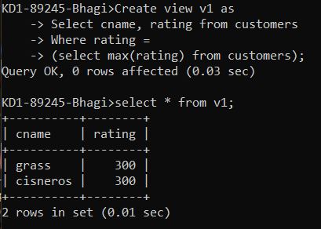

1. Create a view that shows the number of salespeople in each city.

Create view v2 as

Select count(snum), city from salespeople

Group by city;

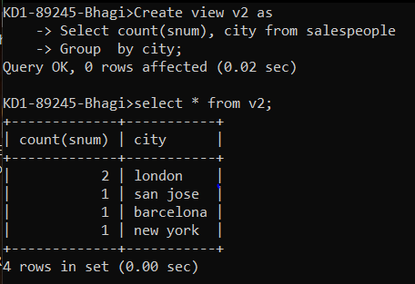

1. Create a view that shows the average and total orders for each salesperson after his or her name. Assume all names are unique.

Create view v3 as

Select s.sname as salesperson_name,

Count(o.onum) as total_orders,

Avg(o.amt) as avg_order_amount

From salespeople s left join orders o on s.snum = o.snum

Group by s.sname;

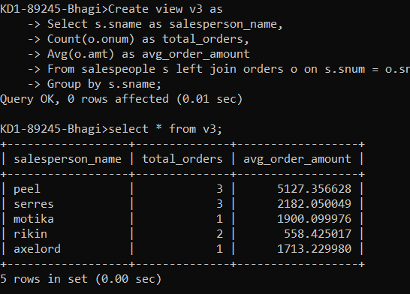

1. Create a view that shows each salesperson with multiple customers

Create view v4

As

Select snum, count(distinct cnum)

From customers

Group by snum

Having count(distinct cnum) > 1;

